|  |
| --- |
| **International School**  Đồ Án CDIO  **CMU-CS 447**    Architecture Document  Version 1.0  Date: 05- April - 2025  Airline Reservation System  Submitted by  Nguyen Pham Anh Huong  Cao Minh  Le Minh Hieu  Nguyen Thi Thanh Huong  **Approved by**  **Capstone Project 1 - Mentor:**  Name Signature Date  Tinh, Le Van __________________04 - April- 2025 |

Table Contents

**PROJECT INFORMATION 1**

**DOCUMENT INFORMATION 2**

**REVISION HISTORY 3**

**1. INTRODUCTION 4**

1.1. PURPOSE 4

1.2. DEFINITIONS, ACRONYMS AND ABBREVIATIONS 4

1.3. DOCUMENTS REFERENCES 4

**2. PROBLEM STATEMENT 4**

2.1. PROJECT OVERVIEW 4

2.2. BUSINESS DRIVERS 4

2.3. PROJECT GOAL 5

**3. ARCHITECTURE DRIVERS 5**

3.1. HIGH-LEVEL REQUIREMENTS 5

3.2. SYSTEM CONTEXT 6

3.3. QUALITY ATTRIBUTES 7

**4. CONSTRAINTS 8**

4.1. BUSINESS CONSTRAINTS 8

4.2. TECHNICAL CONSTRAINTS 8

**5. HIGH-LEVEL ARCHITECTURE 9**

5.1. COMPONENT AND CONNECTOR VIEW (C&C VIEW) 9

5.2. MODULE VIEW 11

**6. LOW-LEVEL ARCHITECTURE 17**

6.1. Database Design 17

6.2. RDF DATA CUBES 18

**7. REFERENCES 22**

# PROJECT INFORMATION

|  |  |  |  |
| --- | --- | --- | --- |
| **PROJECT INFORMATION** | | | |
| **Project Acronym** | ARS | | |
| **Project Title** | Airline Reservation System | | |
| **Project Web URL** |  | | |
| **Start Date** | 5-Apr - 2025 | | |
| **End Date:** | 24 - May - 2025 | | |
| **Lead Institution** | International School, Duy Tan University | | |
| **Project Mentor** | M.Sc Tinh, Le Van | | |
| **Scrum Master** | Minh, Cao | Minhcao05092004@gmail.com | 0905575080 |
| **Team Members** | Huong, Nguyen Thi Thanh | nguyennguyenkhanhquynh@gmail.com | 0358692336 |
| Huong, Nguyen Pham Anh | ahhuong312@gmail.com | 0774442236 |
| Hieu, Le Minh | lhieu20231@gmail.com | 0901942400 |

Table 1 - Project Information

# DOCUMENT INFORMATION

|  |  |  |  |
| --- | --- | --- | --- |
| **DOCUMENT INFORMATION** | | | |
| **Document Title** | Architecture Document | | |
| **Author(s)** | Group 3 | | |
| **Role** | Architecture_v1.0 | | |
| **Date** | 5-Apr - 2025 | File name | Architecture_v1.0 |
| **URL** | https://github.com/nnkq/myproject.git | | |
| **Access** | Project and CMU Program | | |

Table 2 - Document Information

## 

# REVISION HISTORY

|  |  |  |  |  |
| --- | --- | --- | --- | --- |
| **Version** | **Person(s)** | **Date** | **Description** | **Approval** |
| 1.0 | All members | 5-Apr - 2025 | Initiate Architecture Document | x |
|  |  |  |  |  |
|  |  |  |  |  |
|  |  |  |  |  |

Table 3 - Revision History

# INTRODUCTION

## PURPOSE

The purpose of the Architecture document is to:

* Define the architecture needs and technology in detail.
* Provide solutions for business needs.
* Provide overview about resources, schedule, solution and budget for the project.

The architecture merely introduces the project to the student development teams, and provides the up-front information necessary for the team to develop a specification.

## DEFINITIONS, ACRONYMS AND ABBREVIATIONS

|  |  |
| --- | --- |
| **Acronyms** | **Definitions** |
| ARS | Airline Reservation System |
| GUI | Graphical User Interface |
| SDK | Software Development Kit |
| ES | ECMAScript language |

## DOCUMENTS REFERENCES

|  |  |
| --- | --- |
| **No.** | **Reference** |
| 1 | Product Backlog Document for ARS |
| 2 | Project Plan Document for ARS |

# PROBLEM STATEMENT

## PROJECT OVERVIEW

The Airline Reservation System (ARS) aims to provide an efficient, user-friendly platform for managing flight bookings, passenger information, and airline operations. The system automates the reservation process, enabling customers to search, book, and manage flights while allowing administrators to oversee schedules, pricing, and user data.

## BUSINESS DRIVERS

**Business problem:**

The airline industry struggles with inefficient, outdated reservation systems that cause complex booking processes, operational errors, and poor customer experiences, leading to revenue loss and dissatisfaction. Manual processes, limited accessibility, insecure payment methods, and scalability issues hinder real-time management of flights, pricing, and customer data. Additionally, the lack of personalized options and automated notifications alienates customers and reduces engagement. An Airline Reservation System is needed to automate bookings, centralize data, ensure secure transactions, and provide a user-friendly, scalable platform, ultimately improving efficiency, customer satisfaction, and competitive advantage.

**Business need:**

Airline Reservation System have specific uses:

* Provide an intuitive, fast, and responsive search interface to improve customer satisfaction and retention.
* Offer advanced filtering options (e.g., stops, airlines, time of day) to stand out in a crowded market.
* Display higher-margin flights or partner deals prominently to increase revenue per booking.
* Ensure the search system can handle high query volumes during peak travel seasons.

All the things above are based on the functionality of the Airline Reservation System. ARS fully meets these requirements. Therefore, the development of ARS is very necessary and meaningful.

## PROJECT GOAL

This project will launch a transformative flight reservation system that blends scalability, real-time functionality, and user-centric design. By delivering lightning-fast flight search and filtering, secure multi-payment options, instant automated notifications, and a data-driven admin dashboard, the platform will maximize customer satisfaction, streamline operations, and position the business as a leader in the travel industry.

# ARCHITECTURE DRIVERS

## HIGH-LEVEL REQUIREMENTS

The ARS uses a microservices-based architecture deployed on Google Cloud, leveraging Spring Boot (Java) on the server and React + Redux on the client.

Core components include:

* Frontend (React): For user interaction and booking flows
* Backend (Spring Boot): For REST APIs, business logic
* Database (PostgreSQL): For transactional data
* Analytics Layer (OLAP → RDF): For reporting and visual insights
* Notification System: For SMS/email updates using Twilio/SendGrid
* Authentication: JWT-based secure access control

## SYSTEM CONTEXT

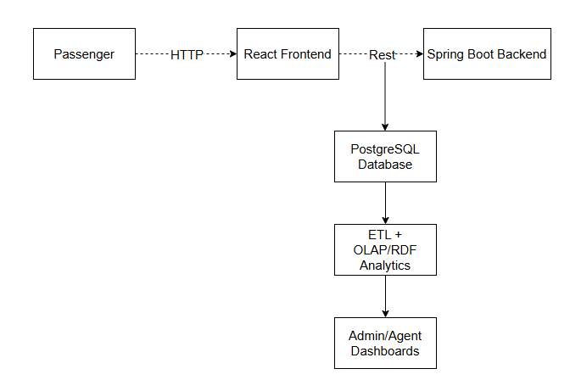

**Figure 3.2**: Context Diagram of System

Prose:

* **Data Sources :**
* Collect from environment open data platforms of the governments and NGO organizations.
* Use web crawling techniques to crawl data from related environment websites.
* Data Format : CSV, JSON, XML.
* **ETL (Extract, Transform, Load )**
* **Extract :**
* In this step, data is extracted from the source system into the staging area. Transformations if any are done in the staging area so that performance of source system is not degraded. Also, if corrupted data is copied directly from the source into the data warehouse database, rollback will be a challenge. Staging area gives an opportunity to validate extracted data before it moves into the Data warehouse.
* **Transform :**
* Data extracted from the source server is the raw data and not usable in its original form. Therefore it needs to be cleansed, mapped and transformed. In fact, this is the key step where the ETL process adds value and changes data such that insightful reports can be generated. In the transformation step, we filter , clean, split and integrate the data to match with the system requirements and data warehouse architecture.
* **Load :**
* Loading data into the target data warehouse database is the last step of the ETL process.
* **OLAP**
* In this step, we export the data from the data warehouse as RDF data cubes for better query performance, data binding and scalability, in addition for information transparency.
* **Dashboard**
* In this step, the user can drag any data cubes that appear as items on the sidebar and drop onto the main content board, then connect between them and use the operator such as statistics merge, geo merge to build a new data cube that matches the user requirement.
* **Viz & AI**
* This step will perform the data cube which was created by the user with the form they want. It can be a map, a column chart, a line chart or a pie chart.

## QUALITY ATTRIBUTES

|  |  |
| --- | --- |
| **ID** | **QA01** |
| **Quality Attributes** | Performance |
| **Stimulus** | Multiple users search for flights or book tickets simultaneously |
| **Source(s) of stimulus** | Passenger |
| **Artifacts** | Flight |
| **Environment** | Under peak load |
| **System response** | Results returned within acceptable response time |
| **Response measure(s)** | Within 2 seconds |

**Table 3.3.1:** Quality Attributes: Performance

|  |  |
| --- | --- |
| **ID** | **QA02** |
| **Quality Attributes** | Availability |
| **Stimulus** | A server failure or system crash occurs during booking or check-in |
| **Source(s) of stimulus** | Airline staff, passengers, or backend processes |
| **Artifact** | Reservation system server, payment service, flight status API |
| **Environment** | Normal operation or during peak travel seasons |
| **System response** | System switches to a redundant server or displays a graceful error page |
| **Response measure(s)** | Less than 1 minutes |

**Table 3.3.2:** Quality Attributes: Availability

|  |  |
| --- | --- |
| **ID** | **QA03** |
| **Quality Attributes** | Security |
| **Stimulus** | Unauthorized user attempts to access payment or passenger data |
| **Source(s) of stimulus** | External attacker or compromised device |
| **Artifact** | User authentication, payment module, PNR database |
| **Environment** | System running normally |
| **System response** | Detect and block access; log incident; notify admin |
| **Response measure(s)** | 100% of unauthorized access attempts are blocked, alerts generated |

**Table 3.3.3:** Quality Attributes: Security

# CONSTRAINTS

## BUSINESS CONSTRAINTS

* Project will be started on 5 - Apr - 2025
* Project will be finished on 24 - May - 2025
* Duration: 7 weeks

## TECHNICAL CONSTRAINTS

Main Programming Language: Javascripts, Python.

**Data Warehouses:**

* Programming Language: Python.
* Database: PostgreSQL.
* Library: Psycopg2, CSV, Unidecode.

**Data Cubes**

* Programming Language: RDF-Graph, SPARQL.
* Tool for converting from Datawarehouse to RDF Data Cube : OpenRefine.
* Storing Platform & Endpoint : GraphDB.
* Network Accessing: RDF-REST API.

**Server:**

* Programming Language: Javascripts.
* Framework: ExpressJS (NodeJS).
* Libraries: Node-Postgres.
* Operating System: Windows, Linux, MacOS.
* Deployment Environment: Google Cloud with App Engine and SQL Services.
* Network Accessing: HTTP methods (POST, GET) via RESTful API.

**Client:**

* Programming language: HTML, CSS, Javascripts.
* Framework: React, Redux.
* Libraries: Material-UI, react-dnd, beautiful-react-diagrams, highcharts
* Deployment Environment: Google Firebase Hosting
* Operating System: Windows, Linux, Mac OS.
* Web Browser: Chrome, Firefox, Microsoft Edge, Coccoc
* Network Accessing: World Wide Web (WWW), HTTP methods (POST, GET) via RESTful API

# HIGH-LEVEL ARCHITECTURE

## COMPONENT AND CONNECTOR VIEW (C&C VIEW)

The diagram below shows the overview architecture including components and other related components. We have representations and behaviors for import components in the following sections

*References C&C View on attached page.*

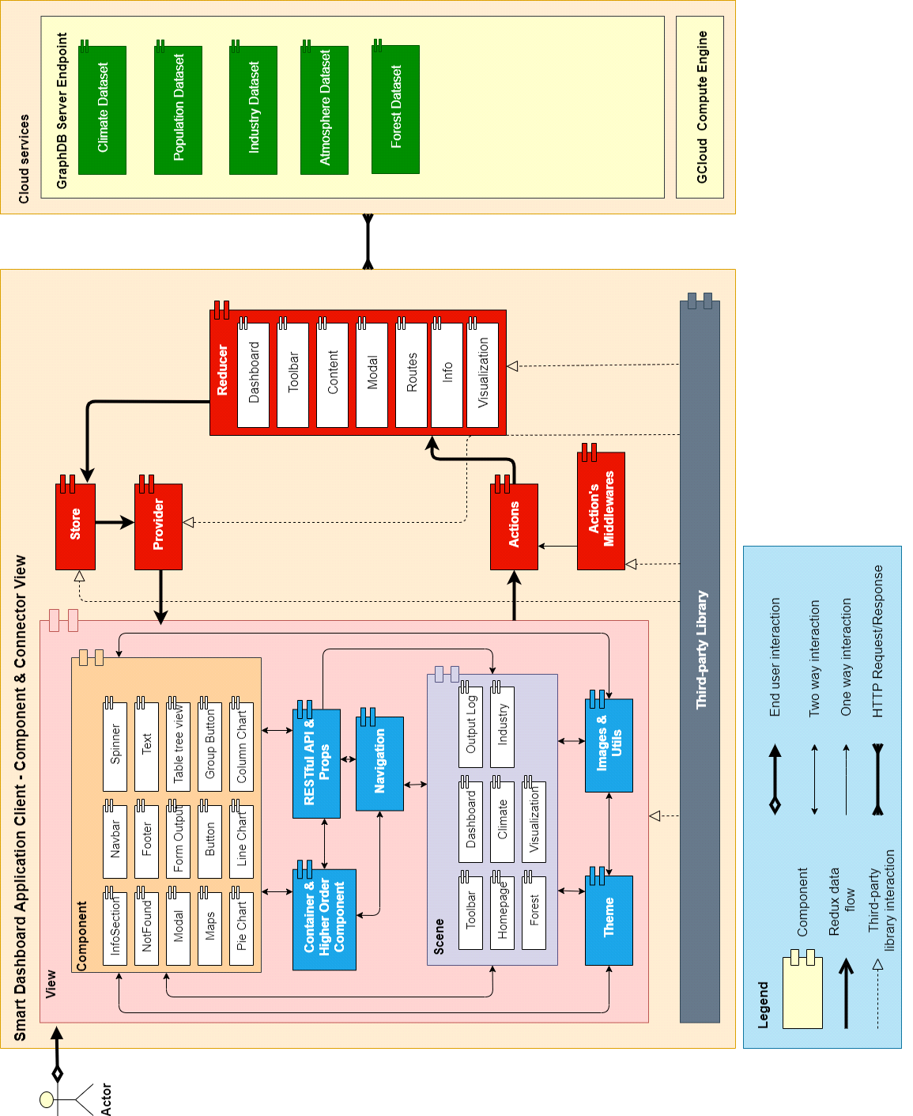

**Figure 5.1:** C&C View

**Prose:**

When the end-user opens the application, GUI will appear. Users will interact with the View component. The View component includes some small components like Toolbar, Content, Description and Util, Scene, Navigation, Container and Higher Order component, and some other components (The View component will be detailed in Model View). If User has any action, View will call the Actions component. Actions will format the requirement and send it to the Reducer. The Reducer will send a state tree to the Store. The Store will replace the old state tree with a new one. The Provider is a component that helps connect Store and View, it will get the new state from Store and send it back to View. Third party libraries will help the application run faster and reduce the code time.

Any time when the application needs to use data, it will call Cloud service. Cloud service includes Graph server endpoint. We place our server on GCloud and implement the application API on it.

|  |  |
| --- | --- |
| **Role & Responsibility** | **Description** |
| **View** |  |
| Component | Components let you split the app into independent, reusable pieces, and think about each piece in isolation. |
| Scene | The Scene transform represents the app in UI. |
| Container & Higher Order Component | Pattern that has proven to be very valuable for several React libraries |
| Restful API & Props | Provides a data in your API & render in child |
| Navigation | Provides an easy to use navigation solution, |
| Theme | Defining set of styles. |
| Images & Utils | Storing images or utils library. |
| Store | The Store is the object that brings all together. |
| Provider | Make the store available to all container components in the application without passing it explicitly. |
| Actions | Actions are payloads of information that send data from your application to your store. |
| Actions’s Middlewares | It provides a third-party extension point between dispatching an action, and the moment it reaches the reducer. |
| Reducer | Actions describe the fact that something happened, but don't specify how the application's state changes in response. This is the job of reducers. |
| Third-party Library |  |
| GraphDB Server Endpoint | Build and ship our APIs faster and more consistently. Not having to worry about authentication, performance and status monitoring has reduced the time and effort we need to build great APIs |
| API: | Set of functions and procedures that allow the creation of applications which access the features or data of an operating system, application, or other service. |

## MODULE VIEW

* Module View based on Web Application

*References Module View on attached page.*

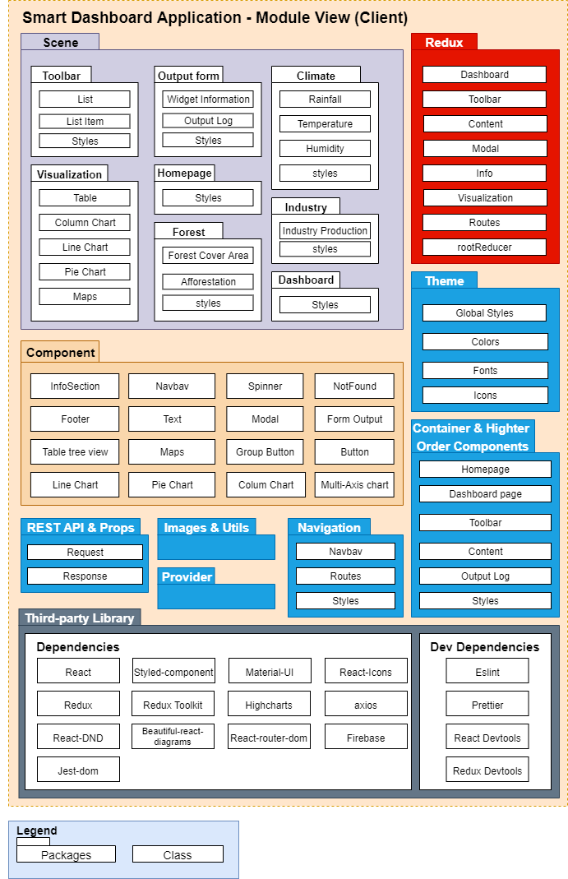

**Figure 5.2.1:** Module View Client

Prose:

The SDA client application includes 10 packages that help the app run effectively.

The Scene package includes

Component package which has 16 classes which is often used and we custom it to fit our requirement. We also have Theme package to define the app format. It will define the app color, font, icon, and metric.

Navigation package contains a Navbar, Routes and its Style.

Redux package also has Dashboard, Toolbar, Content, Modal and root Reducer class to manage the state. Our Component and Higher Order Components is an advanced technique in React that is used in reusing components. Higher Order Components are not part of the React API. Specifically, a higher-order component is a function and it takes the argument as a component and returns a new component.

Images and Utils package contain the app image and functions to solve app general problems.

In third-party libraries, we have Dependencies and Devdependencies class.

Beside it, We have Dev Dependencies class like EsLint, Prettier, React Dev Tool and Redux Dev Tool to manage the code and make sure that our code follows the general format.

Finally, when the app wants to use data, it will connect to cloud service. Cloud service includes GraphDB and GCloud service

|  |  |
| --- | --- |
| **Role & Responsibility** | **Description** |
| Styles | Defining styles |
| **Scene** | |
| Toolbar | Display list of datacube & dataset |
| Output form | Widget Log |
| User Guide | Help user can use app easily |
| Homepage | Home page of web |
| Dashboard | Higher Order Component that wrap toolbar, mainboard, Information Widget |
| Climate | DataCube |
| Industry | DataCube |
| Forest | DataCube |
| **Component** | |
| InfoSection | Section Information |
| Navbar | Navigation |
| Spinner | An UI when page is loading |
| NotFound | An UI when Page when 404 error |
| Footer | Footer |
| Form Input | A text field is used for form |
| Text | A general text is used for all text in this application |
| Modal | Modal Component is inherited Modal of Material-UI |
| Button | Button |
| Group Button | List of button |
| Custom Node | Widget of each datacube & visualization |
| Line Chart | Visualization data from data cube in chart |
| Column Chart | Visualization data from data cube in chart |
| Pie Chart | Visualization data from data cube in chart |
| Maps | Visualization data from data cube in maps |
| **Redux** | |
| Dashboard | A Redux store & reducer for handling state of Dashboard |
| Toolbar | A Redux store & reducer for handling state of Toolbar |
| Content | A Redux store & reducer for handling state of Content |
| Modal | A Redux store & reducer for handling state of Modal |
| Routes | Define routes of scenes for navigation |
| rootReducer | A combination of all defined reducer & third party reducer |
| **Theme** | |
| Global Styles | Defining styles |
| **Container & Higher Order Components** | |
| Homepage | Responsible for handling homepage, about, contact routes |
| Dashboard page | Responsible for handling dashboard routes & |
| Toolbar | Handle list item & drag & drop from Toolbar to Content |
| Content | Handle widget node & connector in Mainboard |
| Outputlog | Handle widget information & data log |
| **Rest API & Props** | |
| Request | Used to send request to get data from server |
| Response | Used to get data when requesting success, such as humidity, temperature,.... |
| **Images & Utils** | |
| **Provider** | |
| **Navigation** | |
| Navbar | A List of buttons such as: New, Help, Example1,... |
| Routes | Define routes of scenes for navigation |
| **Third-party Library** | |
| Dependencies | A list of dependencies that is required for operating the application |
| DevDependencies | A list of dependencies that is required for development environment |

* Module View based on Server

*References Module View - Server on attached page.*

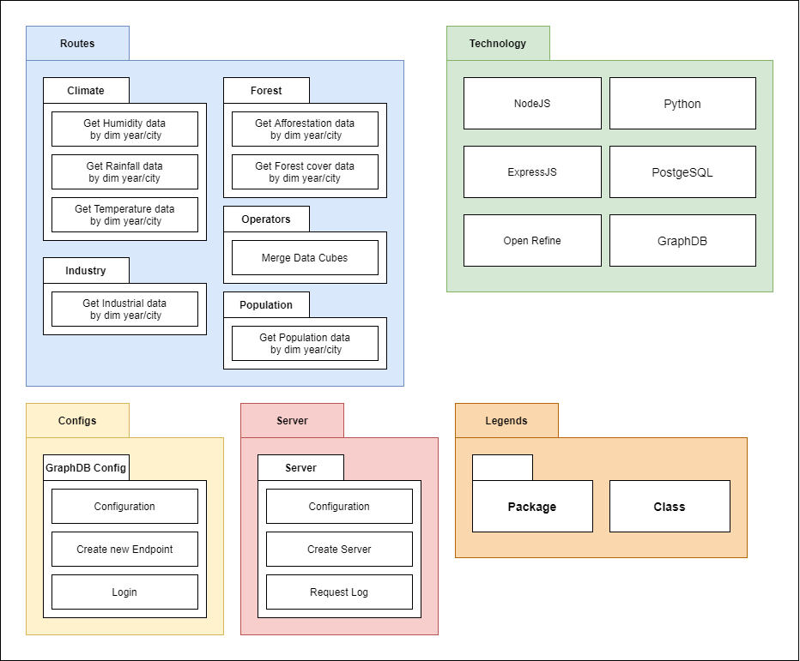

**Figure 5.2.2:** Module View - based on Server

Prose:

|  |  |
| --- | --- |
| **Role & Responsibility** | **Description** |
| **Routes** | GET HTTP actions |
| Climate | Get data of climate data cube ( humidity, rainfall, temperature values ) by dimension year and city |
| Forest | Get data of forest data cube ( afforestation area, forest cover value ) by dimension year and city |
| Industry | Get data of industry data cube by dimension year and city |
| Population | Get data of population data cube by dimension year and city |
| Operators | Execute merging 2 or 3 data cubes for creating a new data cube |
| **Configs** | |
| GraphDB Config | Initiate configuration values for GraphDB, create a new SPARQL Endpoint, login to GraphDB |
| **Server** | |
| Server | Initiate configuration values for creating an ExpressJS server, log the requests from clients |
| **Technology** | |
| ExpressJS | Library for programming API |
| NodeJS | Library for programming API |
| Open Refine | A reconciliation service for registered SPARQL endpoints, a graphical user interface(GUI) for exporting data of Google Refine projects in RDF format. The export is based on mapping the data to a template graph using the GUI. |
| Python | Programming Language for building ETL process |

* ALLOCATION VIEW

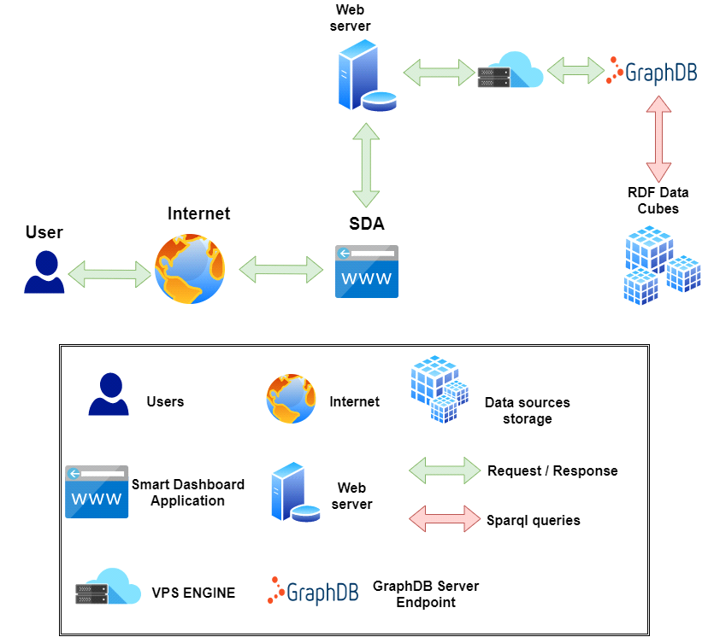

**Figure 5.3:** Allocation View

Prose:

The user can access our web app via the internet. When they use it, the web app will connect to the GCloud server to get the data via the internet.

|  |  |
| --- | --- |
| **Role & Responsibility** | **Description** |
| Data sources storage | RDF Data Cubes is stored on GraphDB |
| User | User that interact with SDA |
| Web server | HTTP Server with NodeJS |
| Smart Dashboard Application | Our application. |
| VPS Engine | Store and Execute SDA's server |
| GraphDB Server Endpoint | Stage to received and run SPARQL for interacting with the data cubes |
| Request / Response | Get request metadata from client and response the data to client |
| SPARQL queries | Query language for execute the method of RDF Data Cubes |

# LOW-LEVEL ARCHITECTURE

## Database Design

* Data warehouse architecture

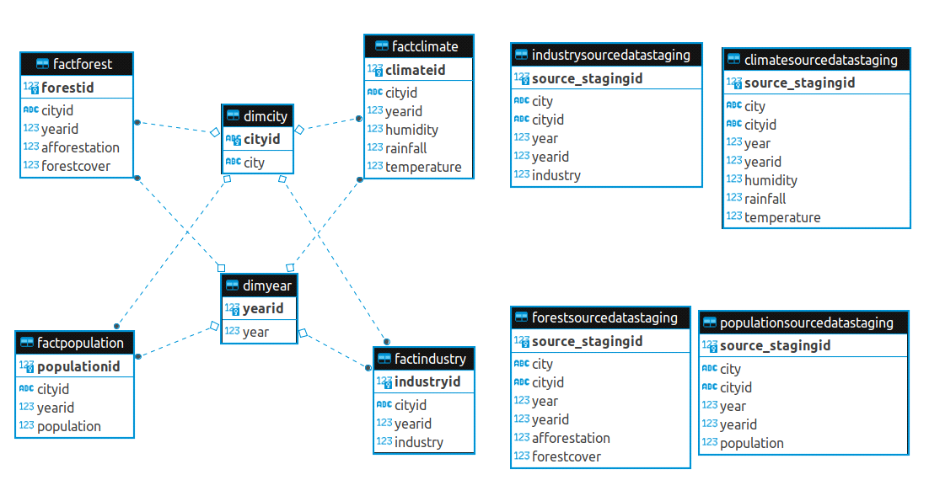

**Figure 6.1.1:** Data warehouse Schema

A data warehouse is subject oriented as it offers information regarding a theme instead of companies' ongoing operations. These subjects can be sales, marketing, distributions, etc.

A data warehouse never focuses on the ongoing operations. Instead, it put emphasis on modeling and analysis of data for decision making. It also provides a simple and concise view around the specific subject by excluding data which is not helpful to support the decision process.

* Star schema, Fact Tables and Dimension Tables

The star schema architecture is the simplest data warehouse schema. It is called a star schema because the diagram resembles a star, with points radiating from a center. The center of the star consists of a fact table and the points of the star are the dimension tables.

A fact table typically has two types of columns: foreign keys to dimension tables and measures those that contain numeric facts. A fact table can contain fact's data on detail or aggregated level.

A dimension is a structure usually composed of one or more hierarchies that categorizes data. If a dimension hasn't got hierarchies and levels it is called flat dimension or list. The primary keys of each of the dimension tables are part of the composite primary key of the fact table. Dimensional attributes help to describe the dimensional value. They are normally descriptive, textual values. Dimension tables are generally smaller in size than fact tables.

Typical fact tables store data about sales while dimension tables data about geographic region (markets,cities), clients, products, times, channels.

SDA database system is designed based on the data warehouse platform. In SDA data warehouse, there are three main concepts (table types), those are staging area table, dimensional table and fact table with star schema:

* Staging area tables: Climate Staging area, Forest Staging area, Industry Staging area, Population Staging area.
* Dimensional tables: dimyear table, dimcity table.
* Fact tables: factclimate table, factforest table, factindustry table, factpopulation table.

## RDF DATA CUBES

* RDF DATA CUBES DESIGN

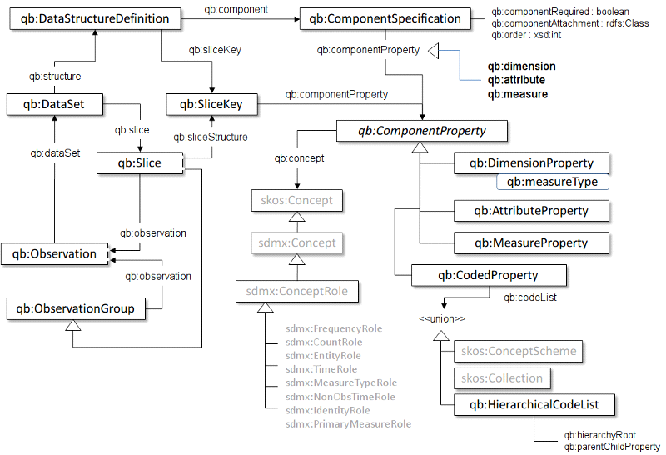

**Figure 6.2:** Pictorial summary of key terms and their relationship.

* RDF Data cubes Architecture

The vocabulary of the RDF Data Cube was recently proposed as a W3C recommendation for the destruction of various mathematical data using the RDF format. The model under this vocabulary is based on the SDMX model, the ISO standard for representing statistical data that can be shared between organizations. . The data cube, called the dataset, is an example of class qb:Dataset. Cube data cells, called observation, are the conditions of phase qb:Observation. Each look can have one or more attributes, sizes, and dimensions of a structure. Features defining qb type steps: MeasureProperty. This positive relationship correlates with recognition and measurement values ​​(e.g., value of humidity), which have a range of numbers. Qualities and sizes of species qb:AttributeProperty and qb:DimensionProperty, respectively. The size represents the viewing context (e.g., the city in which the humidity is calculated), while the attributes provide additional information about the measure, such as the unit of measure.

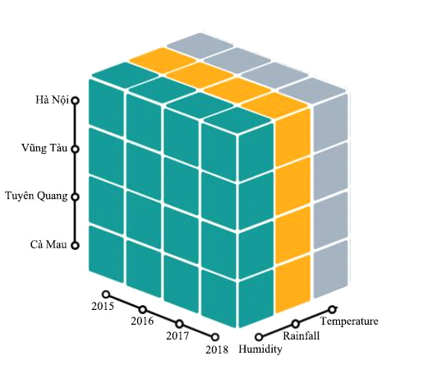

**Figure 6.2.1:** Climate Data Cube in 3D  
  
  
**Figure 6.2.2:** Climate Data Cube Structure

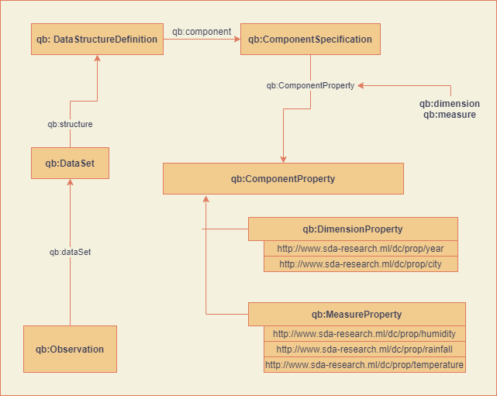

As the schema above, the Data Structure Definition has a child node ComponentSpecification, where qb:ComponentProperty is configured. The qb:ComponentProperty includes two main concepts, qb:DimensionProperty and qb:MeasureProperty - the DSD definitions for each dimension and measure in the data warehouse. Each class has an specific URI that is regulated for querying with SPARQL Endpoint and makes the Linked Data Structure for the Data Cube.

For instance, The Climate Data Cube structure has:

* Dimensions:
* City : Hà Nội, Vũng Tàu, Tuyên Quang, Cà Mau,etc...
* Year : 2015, 2016, 2017, 2018,etc...
* Measures:
* Humidity
* Rainfall
* Temperature
* Observations:
* Humidity value of Hà Nội in 2015, 2016.
* Rainfall value of Cà Mau in 2015, 2016.
* Temperature of Tuyên Quang in 2017, 2018.
* ...etc...

When a user need to figure out a set of statistical data that depends on multiple categories, such as humidity of an area/city in a specific time period (year), the data cube will refer to the statistics value (observation) of the measure (humidity) that match the dimension (city, year).

For instance, this is the observation of the rainfall value of Tuyen Quang in 2015.

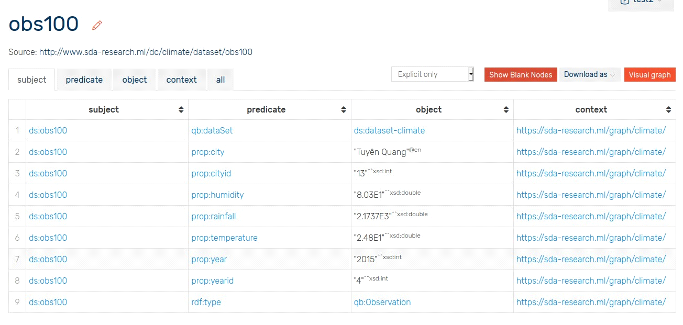

**Figure 6.2.3:** Observation 100th.

* APPLICATION APIS

For interacting between client and server, we choose to deploy SDA onto a Linux Virtual Private Server. Using Linux VPS, it is very easy and simple to develop, maintain and especially run the server in the most stable way.

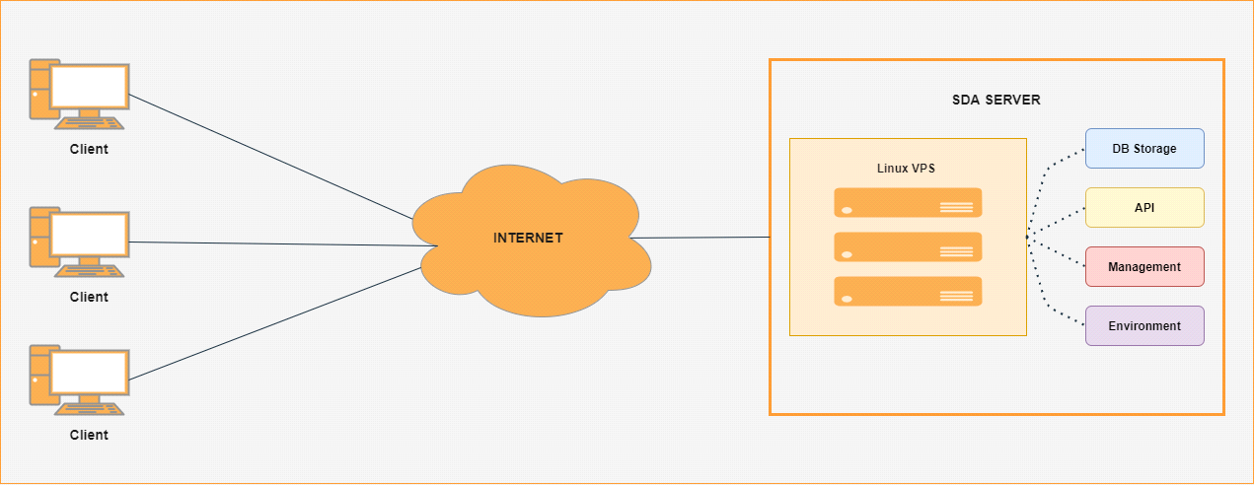

**Figure 6.2.4:** Deployment Diagram

We write the APIs of SDA system with enapso-graphdb library, a Javascript library that give developers the most flexible way to configure, connect and interact with OntoText GraphDB platform, and the help of Express.JS, the most famous also strongest NodeJS library for building REST API server.   
  
In the SDA system, because that is a data representing and integrating system, thus the main HTTP method we use in API development is the GET method. Specifically, with each data cube, we design separate GET methods for querying the data cube based on the requirements of clients. Below is the routes map of the SDA system.

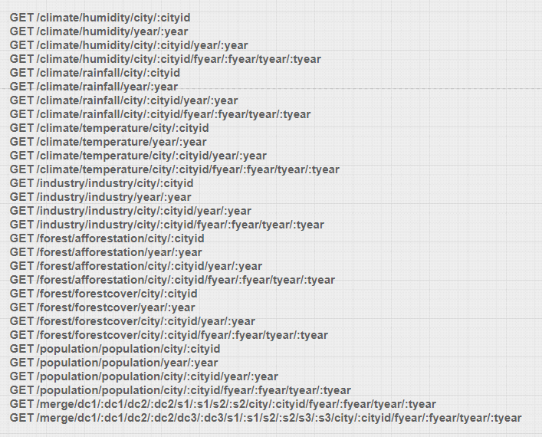

# REFERENCES

* Server Endpoint: [http://server.sda-research.ml](http://server.sda-research.ml/)
* Draw.io: [https://www.draw.io](https://www.draw.io/)
* ETL (Extract, Transform, and Load) Process: <https://www.guru99.com/etl-extract-load-process.html>
* Extract, transform, load: <https://en.wikipedia.org/wiki/Extract,_transform,_load>
* What is Extract, Transform, Load? Definition, Process, and Tools: <https://www.talend.com/resources/what-is-etl/>
* ETL - Extract, Transform, Load: <https://www.webopedia.com/TERM/E/ETL.html>
* What is OLAP? Cube, Operations & Types in Data Warehouse: <https://www.guru99.com/online-analytical-processing.html>
* What is OLAP: <https://www.ibm.com/cloud/learn/olap>
* OLAP cube: <https://en.wikipedia.org/wiki/OLAP_cube>
* OLAP (Online analytical Processing): <https://techterms.com/definition/olap>
* The RDF Data Cube Vocabulary: <https://www.w3.org/TR/vocab-data-cube/>
* Optimizing RDF Data Cubes: <http://ceur-ws.org/Vol-1426/paper-02.pdf>
* CubeQA—Question Answering on RDF Data Cubes: <https://www.researchgate.net/publication/313073658_CubeQA-Question_Answering_on_RDF_Data_Cubes>
* RDF Data Cube - graphical representation : <https://www.researchgate.net/figure/RDF-Data-Cube-graphical-representation_fig3_265690180>
* Linked clinical data cube architecture aligned with the RDF data cube: <https://www.researchgate.net/figure/Linked-clinical-data-cube-architecture-aligned-with-the-RDF-data-cube-Depicts-the_fig2_274700091>
* The RDF Data Cube: [https://www.w3.org/TR/eo-qb/#Datacube](https://www.w3.org/TR/eo-qb/" \l "Datacube)
* Data Warehouse Architecture: Types, Components, & Concepts: <https://www.astera.com/type/blog/data-warehouse-architecture/>
* Data Warehousing - Architecture: <https://www.tutorialspoint.com/dwh/dwh_architecture.htm>
* Data Warehouse Architecture: Traditional vs. Cloud: <https://panoply.io/data-warehouse-guide/data-warehouse-architecture-traditional-vs-cloud/>